ABDUL HAKKIM KHAJA BANDE NAWAZ 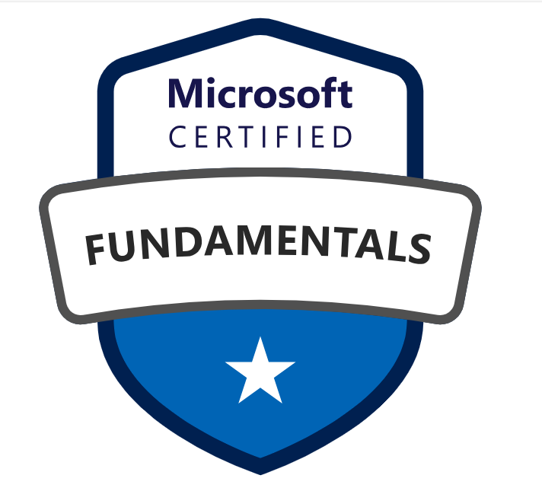  
E-Mail: kh.abdul@gmail.com
Mobile: +1 (480) 9316386 LinkedIn: https://www.linkedin.com/in/abdul-hakkim-kh/
PROFILE SUMMARY:
- Having 15 years of IT experience in Software Development Life Cycle (SDLC). Analysis, design, development and implementation of software applications.
- Proficient in .NET technologies, including .NET Core, ASP.NET Core, ASP.NET MVC, Entity Framework Core, and .NET RESTful Web Services, to build scalable, maintainable applications.
- Experienced in integrating back-end with front-end technologies for seamless, responsive user interfaces, ensuring smooth communication between the client-side and server-side.
- Proficient in creating independent, loosely coupled microservices that communicate via RESTful APIs, utilizing tools like ASP.NET Core Web API and .NET RESTful Services.
- Skilled in designing secure, scalable, and high-performance APIs, implementing features like authentication, authorization, and API versioning, as well as handling JSON and XML data formats for optimal data exchange.
- Security integration expertise, including implementing OAuth2 and JWT to ensure secure communication and user authentication across applications.
- Migrated and refactored core business logic to C#, improving performance, maintainability, and scalability while ensuring functional parity.
- Converted legacy UI (VBA forms / Web Forms / C++ UI) to modern AngularJS templates with responsive design using Bootstrap / Material Design.
- Experienced in frontend frameworks including Angular, NodeJS, ReactJS, TypeScript, and JavaScript, HTML5, CSS3, Bootstrap, AJAX, and jQuery UI for enhanced UI/UX development and to build scalable, dynamic, and responsive web applications.
- Proficient in integrating applications with SQL databases, using Entity Framework Core (EF Core) and ADO.NET for seamless database interaction in ASP.NET Core.
- Skilled in using SQL-based technologies like MSSQL, and MySQL Server for database management and operations.
- Experience in designing, developing, and optimizing SQL queries for CRUD operations (Create, Read, Update, and Delete) to interact with databases efficiently.
- Implemented MongoDB for storing unstructured data and improved API performance through efficient document modeling and indexing.
- Strong testing and debugging skills using tools such as NUnit for unit testing, Selenium for UI testing, and Postman for API testing.
- Proficient in Microsoft Azure, including Azure App Services, Azure Functions, Azure SQL, Azure DevOps (CI/CD pipelines), Azure Service Bus, and cloud deployment best practices.
- Experienced in Azure DevOps practices, including CI/CD automation using GitHub Actions for streamlined builds, testing, and deployments across multiple environments.
- Managed version control using Git and GitHub, ensuring collaboration and code integrity among team members.
- Developed rollback procedures to ensure smooth application upgrades, minimize downtime, and efficiently manage hotfixes during deployment.
- Managed software development platforms using Agile, Scrum, and Waterfall methodologies.
- Domain expertise includes healthcare, airline, and education, with a focus on scalable and high-performance systems.
- Experience working with state education agencies or government educational institutions, delivering customized enterprise solutions for strategic planning, academic management, and administrative workflows.

Professional Experience:
Technical Lead & Full Stack Developer, Omnicron Technologies LLC , US, from January 2025 – Till date.
Title: Modular Revenue Cycle Management (RCM) System - Integrity Health Partners, Columbus, OHIO.
Environment: ASP.NET Core Web API, .NET Core, SQL Server, Angular, Azure DevOps, JWT Authentication, RBAC, ASP.NET Core Identity, RESTful APIs, Visual Studio, Postman, Git.

Responsibilities:
- Designed and developed robust, scalable, and secure .NET Core Web APIs to support critical healthcare services, including claims management, payment processing, and patient records.
- Architected end-to-end solutions prioritizing high availability, performance, and HIPAA-compliant security, meeting healthcare regulatory standards.
- Analyzed existing RCM workflows and legacy code, identifying optimization opportunities and ensuring accurate claims and payment processes.
- Redesigned and implemented core RCM logic in C#, improving performance, maintainability, and scalability.
- Ensured functional parity with legacy systems, validating claims, billing, and payment processing through rigorous testing.
- Developed and maintained RESTful APIs for claims processing and member eligibility using ASP.NET Core and SQL Server; integrated external APIs (EDI 270/271) for real-time insurance eligibility verification.
- Implemented OAuth2, JWT, and Role-Based Access Control (RBAC) in .NET APIs to safeguard sensitive healthcare data.
- Developed and maintained Angular applications for patient billing dashboards, claims tracking, and revenue analytics with seamless integration to .NET APIs.
- Optimized SQL Server performance with advanced indexing, partitioning, stored procedures, and query optimization to support high-volume transactions.
- Utilized MongoDB for managing unstructured patient and transaction data, enhancing API performance with optimized document modeling.
- Published APIs using Azure API Management (APIM) and monitored performance with Azure Monitor and Log Analytics.
- Created unit and integration tests using xUnit and Moq, and collaborated with QA to automate API testing using Postman.
- Performed in-depth debugging of RCM modules, resolving issues in claims processing, payments, and billing workflows to ensure accuracy.
- Developed and executed unit, integration, and UAT test cases to validate RCM functionalities like claims submission, payment reconciliation, and reporting.
- Prepared comprehensive technical and functional documentation for RCM processes, APIs, and data workflows to support maintenance and stakeholder understanding.
- Built and deployed CI/CD pipelines using Azure DevOps and GitHub Actions, reducing manual deployment efforts and accelerating release cycles by 60%.
- Migrated on-premise applications to Microsoft Azure, resulting in a 40% cost reduction and improved scalability and uptime.

Technical Lead & Senior Software Developer, University of Technology and Applied Science (UTAS), Muscat, OMAN, Sep 2016 – Dec 2024.
Environment: Angular, HTML5, CSS3, Bootstrap;.Net, C#, ASP.NET MVC; MSSQL; Git, Azure DevOps.
Responsibilities:
- Led design and development of multiple enterprise-level web applications for academic planning, research, HR, and administrative workflows.
- Specialized in modern UI development using Angular, and TypeScript, integrating with ASP.NET Core Web APIs and MS SQL Server backend.
- Built interactive dashboards using Angular to modernize user interfaces and dynamic data visualizations (charts, tables, goal tracking) for strategic planning modules using reusable components.
- Created responsive interfaces across desktop and mobile devices using Bootstrap, Material UI, and custom CSS.
- Implemented real-time data interactions using REST APIs, lazy loading, form validations, and notifications.
- Developed and maintained unit/integration tests using Jest, React Testing Library, Jasmine, and Karma.
- Migrated legacy systems from ASP.NET Web Forms and Razor Views to modern AngularJS and React-based UI.
- Participated in full SDLC with Agile methodologies: standups, sprints, reviews, and UAT sessions.
- Supported backend development in .NET Core, Entity Framework, and SQL Server for API integration and complex data logic.
- Contributed to CI/CD pipelines and DevOps tasks using Jenkins, Azure DevOps, and Git.

Title: Curriculum Mapping and Development Framework.
Duration: Oct 2014 – November 2016.
We migrated from .NET C# version (ASP.NET VBA C++ & MVC) to a modern AngularJS frontend with C# Web API and MSSQL.

Responsibilities:
- Analyzed existing VBA and C++ applications, including architecture, dependencies, and business logic, to plan migration to C#.
- Identified components to migrate, including UI, business logic, API services, and database interactions, ensuring minimal disruption to existing workflows.
- Redesigned and implemented core business logic in C#, improving maintainability, performance, and aligning with modern coding standards.
- Created new ASP.NET Core Web API project, refactoring legacy procedures and functions into service layers following RESTful principles.
- Converted legacy VBA forms/UI to modern AngularJS templates, leveraging Bootstrap, Material Design, or custom CSS for responsive and user-friendly interfaces.
- Implemented AJAX-based form submissions and refactored legacy UI components to enhance usability and interactivity.
- Implemented Role-Based Access Control (RBAC) and AngularJS authentication guards to secure application routes.
- Optimized database queries, refactored legacy stored procedures, and migrated MSSQL databases to modern versions to improve performance and reliability.
- Conducted thorough debugging, unit testing, and validation to ensure functional parity with legacy VBA/C++ systems.
- Trained team members on modern C# practices, AngularJS best practices, and maintainable code design.
- Successfully deployed C# Web API backend and AngularJS frontend on IIS, ensuring scalability, security, and high performance.

Key Technologies: Frontend: Angular JS, HTML5, CSS3, Bootstrap; Backend: .Net, C#, ASP.NET MVC; Database: MSSQL, or any other relational database; Version Control: Git.
Module Lead – Single Network Application (SNAPP) for Delta Airlines, Hexaware Technologies Pvt. Ltd., Chennai, India From Feb 2011 to Sep 2014.
Environment: Java, Spring Framework, SOAP Web Services, SOA, GWT (Google Web Toolkit), HTML, AJAX, CSS, JavaScript.

Responsibilities:
- Primarily responsible for backend development and integration of SOAP-based services supporting passenger check-in, boarding, baggage handling, and flight connectivity modules.
- Developed and maintained robust service-oriented architecture (SOA) backend components using Spring framework, SOAP web services, and Java technologies.
- Collaborated with frontend UI developers using GWT framework to ensure smooth communication with backend services via SOAP calls.
- Led technical discussions and knowledge transfer sessions to clarify backend requirements and integration points across distributed teams.
- Coordinated daily stand-ups, technical meetings, and demos with downstream teams to align on API contracts, data exchange, and service availability.
- Conducted backend-focused code reviews, ensuring adherence to design patterns, coding standards, and system scalability.
- Assisted QA teams in formulating backend test strategies and troubleshooting service-level issues during integration testing.
- Prepared project estimates and task breakdowns primarily related to backend deliverables and service development.
- Managed defect logging and resolution related to backend services, maintaining close communication with all stakeholders.

Earlier Experience (2007 – 2011):
- Senior Developer, Advantix Technologies Pvt. Ltd., Chennai (Sep 2009 – Jan 2011).
- Developer, Spice Web Pvt. Ltd , Chennai, India (Oct 2008 – Sep 2009)
- Developer, Telic Info Services Pvt. Ltd, Chennai, India (Aug 2006 – Oct 2008)

EDUCATION:
- Master of Computer Application, Anna University; Secured Division - 2006.
- Bachelor of Computer Science, Madras University; secured Division – 2002.

TRAININGS & CERTIFICATIONS:
- Microsoft Certified: Azure Fundamentals
- MTA: Software Development Fundamentals (Microsoft)
- Oracle Certified Java Programmer (OCJP)

Key Skills & Technologies:
- Languages/Technologies (Backend & Others): Visual Basic C++, ASP.NET Core (C#),ASP.NET MVC, .NET Framework, Web API, Entity Framework, NUnit, xUnit, Selenium.
- Languages/Technologies (UI): Angular, ReactJS, JavaScript, TypeScript, HTML5, CSS3, Bootstrap, RESTful APIs, OAuth2, JWT, Swagger.
- Cloud Platform: Azure App Services, Azure Functions, Azure SQL, Azure DevOps (CI/CD pipelines),
- Databases: SQL Server, MySQL, MongoDB (NoSQL).
- Tools and Servers: Visual Studio, Visual Studio Code, Git, GitHub, Azure DevOps, Jenkins, Postman, Swagger, SSRS, Docker, NUnit, xUnit.

